COBBER MEN’S HOCKEY 2004-05

GAME 20 ST. OLAF FEBRUARY 11, 2005 7:00 MOORHEAD YOUTH RINK

GAME #20
St. Olaf College (3-4-3 MIAC/8-6-5)
at
Concordia (3-7-0 MIAC/4-14-1)
February 11, 2005

Moorhead Youth Rink
Moorhead, MN

GAME TIME: 7:00
SERIES: Concordia leads 60-27-3
SERIES STARTED: 1958
LAST YEAR: Last year the two teams split the series in Northfield. The Cobbers won the first game 6-4 and then dropped the finale 3-1. In the opener, Concordia bolted to a 5-2 lead in the second period before the Oles whittled away at the lead and closed to within two. Jon Rudnick and Shawn Kleven each had two goals in the victory. The Cobbers pulled out the win despite being outshot 50-31. In the second game, Matt Hansen scored the opening goal for Concordia but then St. Olaf responded with a single goal in each of the three periods to claim the 3-1 victory. The Oles had the edge in shots for the second night as they outshot the Cobbers 45-24.
SERIES HISTORY: Concordia has only lost once in the past 14 games against St. Olaf. During that stretch the Cobbers own a
10-1-3 record…the two teams have played three overtime games in the past five meetings. The Cobbers won an extra period tilt in 2002-03 and the other two remained deadlocked. There have been eight overtime games in the series…Since the 1988-89 season, Concordia owns an 8-3-2 record against the Oles in Moorhead. During that time, the Cobbers are 7-6-3 in games played in Northfield.

2004 Cobber Men’s Hockey Schedule
Nov. 5 UW-Stout L 4-5 OT
Nov. 6 UW-River Falls L 2-6
Nov. 12 ST. SCHOLASTICA L 4-5
Nov. 13 UW-SUPERIOR L 2-8
Nov. 19 UW-Stevens Point T 4-4 OT
Nov. 20 UW-Eau Claire L 1-4
Nov. 24 UM-CROOKSTON L 3-5
Dec. 3 Augsburg L 1-3
Dec. 4 Augsburg W 6-5
Dec. 10 ST. JOHN'S L 1-6
Dec. 11 ST. JOHN'S L 1-7
Jan. 5 UW-Superior L 1-9
Jan. 14 GUSTAVUS L 0-6
Jan. 15 GUSTAVUS L 1-4
Jan. 26 UM-Crookston W 6-3
Jan. 28 HAMLINE W 4-1
Jan. 29 HAMLINE W 4-2
Feb. 4 St. Mary's L 2-4
Feb. 5 St. Mary's L 2-4
Feb. 11 ST. OLAF 7:00pm
Feb. 12 ST. OLAF 2:00pm
Feb. 18 Bethel 7:00pm
Feb. 19 Bethel 2:00pm
Feb. 25 St. Thomas 7:00pm
Feb. 26 St. Thomas 2:00pm

THE INSIDE SCOOP
CONCORDIA (3-7-0 MIAC/4-14-1)
SENIOR SENDOFF
This weekend marks the last time that the six Concordia seniors will play a regular season series in Moorhead. Matt Hansen, Shawn Kleven, Matt Notermann, Nate Ronning, Steve Rosenfeldt and Adam Sorenson have all made huge contributions to the program. Their dedication and hard work will be hard to replace and they will be definitely missed next season. The entire Concordia athletic department would like to thank the seniors for all the effort and pride they put into playing for the maroon and gold. Good luck after you leave Concordia!
MIRROR, MIRROR ON THE WALL
The Cobbers were dealt a serious blow to their playoff aspirations last weekend in Winona. Concordia dropped a pair of 4-2 games to St. Mary’s. Even though the Cobbers are currently in eighth place in the MIAC standings, they are still holding onto the chance of making the postseason for the sixth time in the past seven years. The reason for Concordia’s possible playoff run is that they play two of the four teams they are battling with for the fourth and fifth playoff spots (five teams make the MIAC postseason tournament). After this weekend’s crucial series with the Oles, Concordia will play at Bethel next weekend. The Royals are currently tied for fourth place with Gustavus. Concordia will finish off the regular season by playing at St. Thomas on February 25-26.
A BALANCED ATTACK
Concordia had four different players score goals in their pair of heartbreaking losses at St. Mary’s last weekend. Noah Katz (So., Columbia, Md./Tilton HS), Shawn Kleven (Sr., Crookston, Minn.), Steve Rosenfeldt (Sr., Moorhead, Minn.) and Mike Vlasak (Jr., Rochester, Minn./Rochester Mayo HS) all scored one goal in the two 4-2 losses in Winona. For Rosenfeldt it was his first goal of the season and first since December 7, 2002.

THE INSIDE SCOOP
ST. OLAF (3-4-3 MIAC/8-6-5)
LAST WEEKEND REWIND
St. Olaf gained four points in a 7-1 and 7-2 drubbing of Gustavus this weekend. In the Saturday win, Ted Bickel assisted on the first goal and scored the next two, including the game-winner with 5:23 left in the second. Bickel's 12 goals lead the Oles and his 20 points (12 g, 8 a) share the team lead with Keith Townsend and Mike MacMillan.
FIT TO BE TIED
St. Olaf has tied five games this season – three in the MIAC alone. Their five ties, is what else, tied with Augsburg and St. Scholastica for the most tied games in all of NCAA Division III this season. The even stranger fact is that the Oles and Auggies tied both of their games this season. At one point during the year, St. Olaf had a three-game tying streak going. In case you were wondering, the five ties represents the most ties in a single season by one team in the history of the MIAC. The three league ties is the second highest total of ties in a conference season in the history of the MIAC.
THE BIG MAC ATTACK
One of the leading scorers for the Oles is freshman Mike MacMillan. MacMillan is currently tied for the team lead in points scored this season (20). He is sixth in the MIAC in scoring in conference games (15). He is also sixth in assists (10), sixth in power play points (7) and tenth in goals scored (5). His 15 points place him first in the league in points scored by a freshman. And where do you think the freshman sensation is from? Maybe the perennial hockey powers Edina, Rochester, Centennial. No, he is from the hockey hotbed of Buffalo, Minn. He also spent time playing in juniors in Billings, Mont.

Cobbers vs. Oles Tale of the Tape
St. Olaf
TEAM STATISTICS CC OPP
SHOT STATISTICS.......
Goals-Shot attempts.49-317 92-472
Shot pct............ .155 .195
Goals/Game.......... 2.6 4.8
Shots/Game.......... 16.7 24.8
Assists............. 45 103
POWER PLAYS...........
Goals-Power Plays...20-128 24-118
Conversion Percent.. .156 .203
Shot Attempts....... 94 123
Shot Percent........ .213 .195
GOAL BREAKDOWN........
Total Goals......... 49 92
Power Play.......... 20 24
Short-handed........ 0 7
Empty net........... 0 2
PENALTIES.............
Number.............. 183 187
Minutes............. 427 407
Penalties/Game...... 9.6 9.8
Pen minutes/Game.... 22.5 21.4

Concordia

TEAM STATISTICS STO OPP
SHOT STATISTICS......
Goals-Shot attempts. 69-539 55-521
Shot pct............ .128 .105
Goals/Game......... 3.5 2.8
Shots/Game......... 27.0 26.1
Assists............ 108 87
POWER PLAYS..........
Goals-Power Plays.. 29-153 24-104
Conversion Percent. .190 .231
Shot Attempts......
Shot Percent.......
GOAL BREAKDOWN.......
Total Goals........ 69 55
Power Play......... 29 24
Short-handed....... 5 2
Empty net.......... 0 0
PENALTIES............
Number............. 125 181
Minutes............ 258 413
Penalties/Game..... 6.3 9.1
Pen minutes/Game... 12.9 29.7

MEET THE COBBERS
Concordia Quick Facts
School: Concordia College
Location: Moorhead, MN 56562
Founded: 1891
Enrollment: 2,826
Nickname: Cobbers
Colors: Maroon and Gold
Facility: Jake Christiansen Complex
Conference: Minnesota Intercollegiate
Athletic Conference (MIAC)
President: Dr. Pamela Jolicoeur
Athletics Director: Dr. Larry Papenfuss
Head Trainer: Stephanie Brandt
Compliance Coordinator: Kerry Norman
National Affiliation: NCAA III
Athletics Phone: 218-299-4434
Athletics Fax: 218-299-4189

Cobber Men’s Hockey Coach

Steve Baumgartner

Steve Baumgartner
became head coach of the
Concordia hockey team in
1986. During his initial
season the Cobbers
captured the conference
championship and
advanced to the NCAA Division III National tournament by winning the MIAC playoffs.

He was named the MIAC Coach of the Year for the third time in 1999-00 after leading the Cobbers to the NCAA quarterfinals.

Steve was a four-time All-MIAC performer for the Cobbers from 1978 to 1982. Baumgartner was named MVP in the MIAC and also played in the NCAA East-West All-Star Game in 1982 for Division I players. Following the 1982 season, Baumgartner was signed as a free agent to the New York Rangers. Baumgartner later served as the sports program technician for the City of Regina, where he worked mainly with local youth and amateur teams, before joining the Concordia College staff.

Since coming to Moorhead, Steve has also been a coaching staff member of the Blue Line Hockey School, a program that has developed many Division I and Division III players. He is active in both community and church programs. Steve also serves as the assistant coach of the Concordia Woman's Fastpitch team.

Steve grew up in Regina. He and his wife, Lori ('82), live in Moorhead with their two daughters, Jenna and Whitney.

2004-05 Concordia Men’s Hockey Roster

No Name Yr Pos Ht Wt Hometown/Last Team
01 Josh Hand Fr G 6-2 205 Temple, Pa./Thunder Bay (SIJHL)
02 Brett Johnson Jr D 6-0 230 Thief River Falls,Minn/Roch.Mustangs (USHL)

03 Steve Rosenfeldt Sr D 5-9 185 Moorhead, Minn./Moorhead HS
05 Jordan Mackner So F 6-1 195 Moorhead, Minn./Moorhead HS
07 Nate Ronning Sr F 5-11 180 Detroit Lakes, Minn./Bis. Bobcats (AWHL)
08 Jon Rudnick So F 5-11 190 Moorhead, Minn./Des Moines Bucs (USHL)
09 Shawn Kleven Sr F 5-10 185 Crookston, Minn./Crookston HS
10 Noah Katz So F 5-11 195 Columbia, Md./Union College
12 C.J. Bernabucci Fr F 5-7 155 Horace, N.D./UM-Crookston
14 John Wittenberg Fr F 5-11 205 Benson, Minn./Benson HS
15 Dan Perry So F 6-5 225 Fergus Falls, Minn./Fergus Falls HS
16 Mike Vlasak Jr F 5-10 180 Rochester, Minn./Tupelo T-Rex (AWHL)
17 Jim Kennedy Jr F 5-10 195 Princeton, B.C./Elmira College
19 Mark Buchholz So D 6-1 185 Moorhead, Minn./Topeka Scarecrows (USHL)
20 Matt Hansen Sr F 6-0 190 Fargo, N.D./Minot Muskies (AWHL)
21 Adam Sorenson Sr D 5-10 200 Orono, Minn./Orono HS
22 Justin Pethick Fr F 5-7 170 North Branford, Conn./Hrtfd Wolfpack (AJHL)
23 Brice Berggren Jr F 5-10 190 Dassel, Minn./Litchfield-Dassel-Cokato HS
24 Gregg Day Fr D/F 6-1 180 Baxter, Minn./Brainerd HS
25 Matt Notermann Sr F 5-11 185 Rochester, Minn./Minot Muskies (AWHL)
26 Tyler Neu Fr F 6-1 180 Wadena, Minn./Wadena-Deer Creek HS
27 Aaron Bruggeman Jr D/F 6-0 190 Crookston, Minn./DubuqueThunderbirds (MJHL)
28 Keith Paulson Jr F 6-1 200 St.Michael,Minn./DubuqueThunderbirds (MJHL)
29 Mike Dowers Fr G 6-0 195 ThiefRiverFalls,Minn./Hlna Bighorns (NAHL)
33 Justin Simpkins Fr D 6-2 200 Regina, Sask./Fort Knox (SSJHL)
35 Lee Baldwin So G 6-0 180 Horace, N.D./UM-Crookston

Concordia Coaches:
Head Coach: Steve Baumgartner (18th Season; 204-234-30 Overall)
Assistant Coaches: Tony Kunka (6th Season), Craig Tietz (2nd Season)

_________________________________________________________
CONCORDIA MEN’S HOCKEY SENIOR RECOGNITION
#3 Steve Rosenfeldt
Major: Unknown
Post Grad Plans: Unknown
Parents: Dan and Julie
Career Highlights: Scored a
career-high four goals his
freshman season.
Career Stats:
6 goals, 11 assists, 17 points
#7 Nate Ronning
Major: Biology & Chemistry
Post Grad Plans:
Medical School
Parents:
Mari Ronning & Dave Hiney
Career Highlights: Leads
team in assists in 2004-05.
Career Stats:
18 goals, 29 assists, 47 points

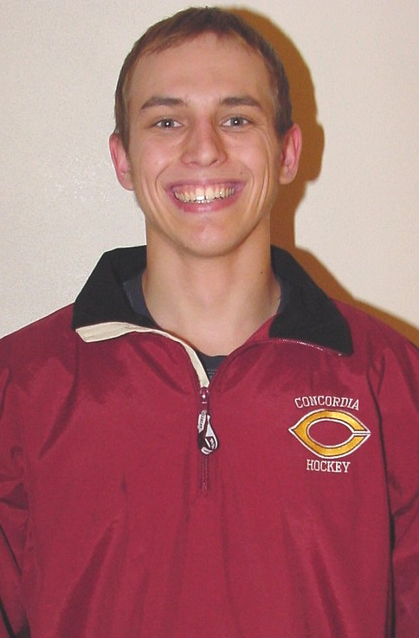
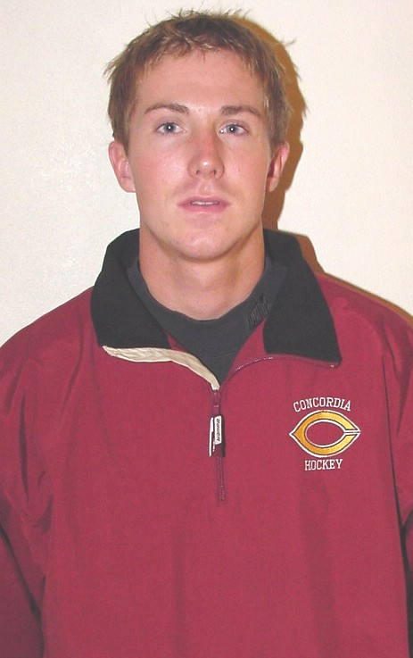

#9 Shawn Kleven
Major: Business
Post Grad Plans: Work
Parents: Scott and Julie
Career Highlights: Named
to the 2003-04 MIAC
All-Conference Honorable
Mention Team.
Career Stats:
23 goals, 20 assists, 43 points

#20 Matt Hansen
Major: English Writing
Post Grad Plans:
Law School
Parents: Wes & Edie
Career Highlights: Leads
team in scoring in 2004-05.
Career Stats:
31 goals, 34 assists, 65 points

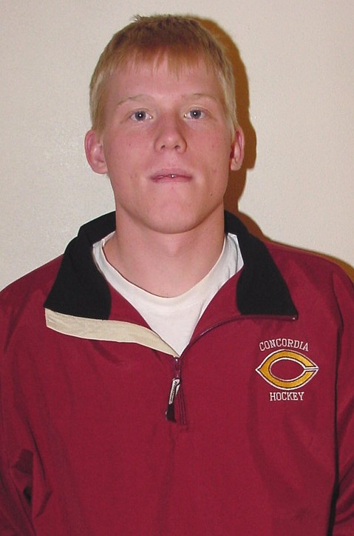
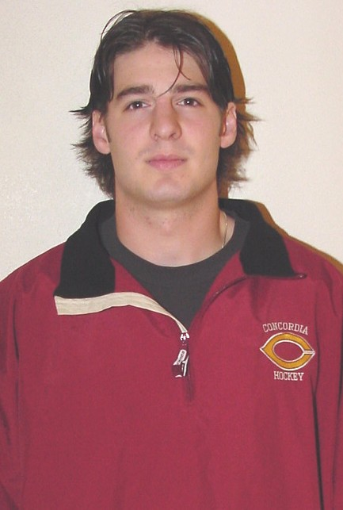

#21 Adam Sorenson
Major: Psychology
Post Grad Plans:
Graduate School
Parents: Larry and Char
Career Highlights: Notched
his first collegiate point vs.
St. Scholastica this season.
#25 Matt Notermann
Major: Biology
Post Grad Plans:
PA School
Parents: John & Denise
Career Highlights: Played
In 88 of the team’s 93 games
the past four years.
Career Stats:
16 goals, 18 assists, 34 points

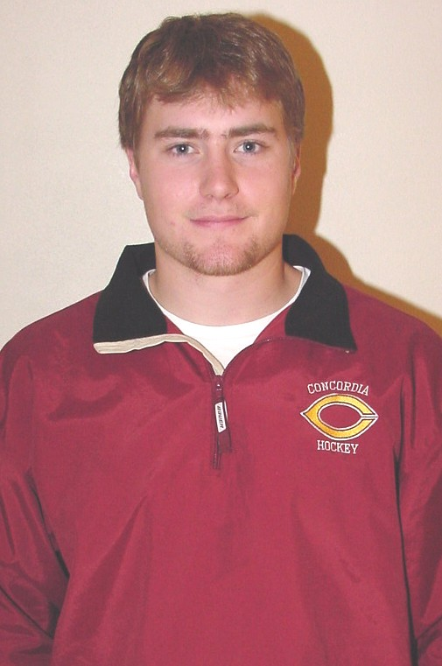
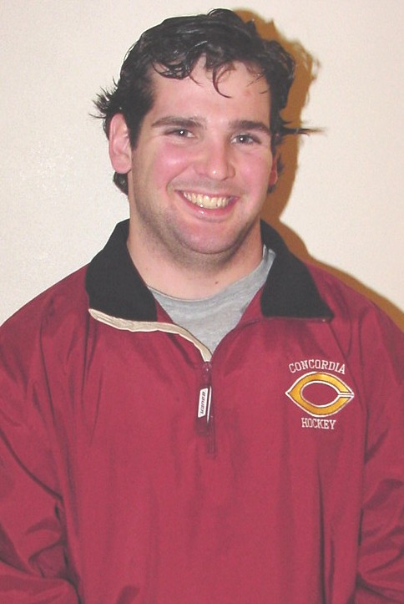

MEET THE OLES

St. Olaf Quick Facts
School: St. Olaf College
Location: Northfield, Minn.
Founded: 1874
Enrollment: 2,900
Nickname: Oles
Colors: Black and Old Gold
Facility: Northfield Ice Arena
Conference: MIAC
President: Chris Thomforde
Athletics Director: Matt McDonald
National Affiliation: NCAA Div. III
Athletics Phone: (507) 646-3834

St. Olaf Head Coach

Sean Goldsworthy
Sean Goldsworthy, an
All-MIAC hockey and
baseball selection and
1994 graduate of St. Olaf,
is in his eighth season as
the Ole's head hockey coach.

Goldworthy led the MIAC in scoring in '94 and was team MVP of the Ole baseball club that was region runner-up his senior season.

After playing two seasons of minor league hockey, Goldsworthy completed his master's at St. Cloud St. University while he was an assistant at Saint John's University.

In addition to his duties as head hockey coach, Goldsworthy teaches biomechanics and is an assistant baseball coach.

He and his wife Amy have two daughters, Madigan and Emma.

St. Olaf 2004-2005 Schedule
Nov. 5 UW-SUPERIOR T 3-3
Nov. 6 ST. SCHOLASTICA W 6-0
Nov. 12 UW-STEVEN'S POINT W 5-3
Nov. 13 UW-EAU CLAIRE L 3-2
Nov. 19 St. Norbert L 5-3
Nov. 20 Lake Forest T 1-1
Dec. 10 Bethel W 6-5
Dec. 11 BETHEL L 3-2
Jan. 4 UW-River Falls W 5-2
Jan. 5 SAIT L 9-7
Jan. 7 Lawrence W 5-3
Jan. 8 Lawrence W 6-1
Jan. 14 ST. THOMAS L 7-3
Jan. 15 St. Thomas L 4-1
Jan. 21 AUGSBURG T 1-1
Jan. 22 Augsburg T 3-3
Jan. 29 ST. JOHN'S T 2-2
Jan. 30 St. John's L 6-1
Feb. 4 GUSTAVUS W 7-1
Feb. 5 Gustavus W 7-2
Feb. 11 Concordia 7:00 p.m.
Feb. 12 Concordia 2:00 p.m.
Feb. 18 HAMLINE 7:00 p.m.
Feb. 19 Hamline 7:00 p.m.
Feb. 25 ST. MARY'S 7:00 p.m.
Feb. 26 St. Mary's 7:00 p.m.

2004-05 St. Olaf University Roster
No Name Yr. Pos. Ht. Wt. Hometown
01 Jeff Wilde So. G 5-11 175 Watertown, S.D.
02 Kyle McDermott So. RD 6-0 175 Kasson, Minn.
03 Matt Rau So. RD 6-1 180 Eden Prairie, Minn.
04 Andy Heyne Sr. LD 6-0 190 Minnetrista, Minn.
05 John Paulson FY LD 6-4 215 Eden Prairie, Minn.
06 Mitch Mudra So. LD 6-0 185 Edina, Minn.
07 Mike Cassano Sr. LF 5-9 180 Littleton, Colo.
08 Ted Bickel Jr. RF 6-3 210 Chanhassen, Minn.
09 Justin Green FY LF 6-3 195 Shorewood, Minn.
10 Brett Kistner FY LF 6-2 190 Peoria, Ill.
11 David Short Sr. RD 5-9 180 Anchorage, Ala.
12 Billy Martin So. RF 5-9 175 Richland, Wash.
13 Patrick Gilles Sr. LF 5-10 175 Waunakee, Wis.
14 Matt Mudra So. LD 6-0 185 Edina, Minn.
15 Andy Ockuly FY RF 5-9 165 Hudson, Wis.
16 Jeff Nordaas FY RF 5-11 180 Washington DC
17 Josh Biser Jr. RF 5-11 190 Waunakee, Wis.
18 John Egge So. LF 5-10 175 Wisconsin Rapids, Wis.
19 Keith Townsend Sr. LF 6-0 200 Sterling Heights, Mich.
20 Spike Therrien FY RF 6-3 200 Brooklyn Park, Minn.
21 Joel Ihrie Jr. RF 6-0 190 Woodinville, Wash.
22 Kyle Hilmershausen So.LF 6-0 185 Wausau, Wis.
23 Kevin Eidsmo FY RD 6-1 185 Chanhassen, Minn.
24 Will Wetterlin Jr. LD 6-0 195 Edina, Minn.
25 Jeff Budish FY LF 6-1 200 Edina, Minn.
26 Andrew Gastineau So. LD 6-0 190 Rochester, Minn.
27 Mike MacMillan FY LF 5-9 180 Buffalo, Minn.
28 Kjell Dybdahl FY LF 5-11 180 Plymouth, Minn.
29 Dan Kehler Jr. G 5-11 180 Woodbury, Minn.
30 Mark Skeba Sr. G 6-0 200 Wheaton, Ill.
33 John Hennessy So. RD 5-9 175 Brookfield, Wis.
35 Eric Hylok FY G 6-2 210 Edina, Minn.
Head Coach: Sean Goldsworthy (8th Season)
Assistant Coaches: Pat Cullen, Scott Macho, Mike Berg

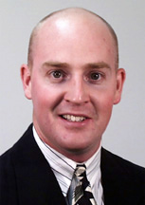

_________________________________________________________
2004-05 St. Olaf Men’s Hockey Statistics
## Player GP G A PTS PEN/MIN PP SH GW GT
8 Ted Bickel 19 12 8 20 12/ 24 7 0 2 1
27 Mike MacMillan 19 6 14 20 3 0 1 0
19 Keith Townsend 19 5 15 20 7/ 14 2 1 2 0
17 Josh Biser 14 7 5 12 1/ 2 6 0 1 0
18 John Egge 17 6 6 12 7/ 14 0 0 0 1
21 Joel Ihrie 18 5 6 11 7/ 14 2 1 0 0
5 John Paulson 18 4 7 11 12/ 24 3 0 0 0
25 Jeff Budish 17 5 4 9 7/ 14 0 1 0 0
22 Kyle Hilmershausen 16 4 5 9 4/ 8 1 1 0 0
24 Will Wetterlin 18 3 6 9 7/ 14 3 0 1 0
13 Patrick Gilles 19 2 7 9 2/ 4 1 1 0 0
9 Justin Green 18 3 4 7 7/ 14 0 0 0 0
6 Mitch Mudra 19 1 6 7 10/ 20 1 0 1 0
26 Andrew Gastineau 17 2 3 5 5/ 10 0 0 0 0
7 Mike Cassano 9 1 2 3 1/ 2 0 0 0 0
10 Brett Kistner 14 0 3 3 14/ 36 0 0 0 0
15 Andy Ockuly 13 1 1 2 1/ 2 0 0 0 0
11 David Short 18 1 1 2 6/ 12 0 0 0 0
23 Kevin Eidsmo 2 0 2 2 0 0 0 0
4 Andy Heyne 16 0 2 2 5/ 10 0 0 0 0
St. Olaf 19 69 108 177 125/258 29 5 8 2
Opponents 19 55 87 142 181/413 24 2 6 3

GOALTENDING
## Name GP Mins GA Sves Pct Record GS SO
29 Dan Kehler 12 744 35 317 .901 5-3-4 12 0
1 Jeff Wilde 6 365 19 180 .905 2-3-1 6 1
30 Mark Skeba 1 60 1 24 .960 1-0-0 1 0
St. Olaf 19 1169 55 521 .905 8-6-5 19 1
Opponents 19 1169 69 539 .887 6-8-5 19 0

COBBER MEN’S HOCKEY 2004-05
GAME 20 ST. OLAF FEBRUARY 11, 2005 7:00 THE BACK PAGE

2004-05 Concordia Men’s Hockey Statistics
## Name GP G A Pts Shots Pct +/- No-Min Min Maj Oth PP SH FG GW GTG
20 Matt Hansen 19 8 9 17 33 .242 -3 17-42 10 0 1 6 0 2 0 0
7 Nate Ronning 19 6 10 16 22 .273 -5 6-12 2 0 0 2 0 3 1 0
9 Shawn Kleven 19 5 6 11 26 .192 -18 2-4 2 0 0 4 0 0 0 0
16 Mike Vlasak 19 5 5 10 28 .179 +1 3-6 1 0 0 3 0 0 0 0
10 Noah Katz 19 6 3 9 26 .231 -12 9-18 7 0 0 1 0 3 0 0
8 Jon Rudnick 18 1 8 9 27 .037 -11 19-38 10 0 0 0 0 0 1 0
19 Mark Buchholz 19 0 9 9 14 .000 -8 1-2 1 0 0 0 0 0 0 0
15 Dan Perry 19 5 2 7 7 .714 -8 6-12 4 0 0 2 0 0 0 0
2 Brett Johnson 19 3 3 6 29 .103 -11 10-20 1 0 0 1 0 1 0 0
28 Keith Paulson 15 2 4 6 8 .250 -2 8-16 6 0 0 0 0 0 0 0
25 Matt Notermann 17 1 4 5 15 .067 -9 20-50 14 0 1 1 0 0 0 0
3 Steve Rosenfeldt 19 1 3 4 6 .167 -17 13-37 8 1 1 0 0 0 0 0
22 Justin Pethick 11 2 1 3 3 .667 +1 0-0 0 0 0 0 0 0 1 0
26 Tyler Neu 18 2 0 2 14 .143 -7 2-4 2 0 0 0 0 1 0 0
17 Jim Kennedy 9 1 1 2 1 1.000 -5 5-10 3 0 0 0 0 1 0 0
27 Aaron Bruggeman 19 0 2 2 9 .000 -4 27-70 17 0 1 0 0 0 0 0
14 Chris Wothe 4 0 2 2 0 .000 -5 7-14 4 0 0 0 0 0 0 0
5 Jordan Mackner 11 1 0 1 6 .167 -8 1-2 1 0 0 0 0 0 0 0
Total...............19 49 75 124 317 .155 -154 183-427 106 1 6 20 0 11 3 0
Opponents...........19 92 147 239 472 .195 - 187-407 103 1 3 24 7 8 13 0

GOALTENDING
## Name GP-GS Minutes GA Avg Saves Pct W L T Sho PP SH EN PEN SOG
29 Mike Dowers 13-8 623:15 41 3.95 366 .899 3 5 0 0 11 2 0 0 0
1 Josh Hand 6-4 227:24 20 5.28 150 .882 0 4 0 0 4 0 0 0 0
35 Lee Baldwin 9-6 287:02 29 6.06 163 .849 1 5 1 0 9 3 0 0 0
Total............... 19-0 1145:25 92 4.82 679 .883 4 14 1 0 24 7 2 0 0
Opponents........... 19-0 1145:25 49 2.57 485 .908 14 4 1 1 20 0 0 0 0

MIAC Standings (as of January 14)
School MIAC Pts GF GA All GF GA Str Home Away
St.John's 10-1-1 21 62 19 18-1-2 110 32 L1 10-0-1 8-1-1
St. Thomas 9-1-0 18 46 20 12-3-4 82 51 W6 7-3-2 5-0-2
Augsburg 4-5-3 11 45 36 7-9-5 74 70 L2 5-4-3 2-5-2
Gustavus 5-5-0 10 38 34 8-11-0 69 71 L2 2-7-0 6-4-0
Bethel 5-5-0 10 36 34 12-7-0 74 59 W1 6-3-0 6-4-0
St. Mary's 4-7-1 9 34 48 8-12-1 67 72 W2 4-6-0 4-6-1
St. Olaf 3-4-3 9 33 34 8-6-5 70 54 W2 3-3-3 5-3-2
Concordia 3-7-0 6 22 43 4-14-1 49 92 L2 2-7-0 2-7-1
Hamline 1-8-0 2 10 56 4-14-0 34 97 L3 2-5-0 2-9-0

MIAC Schedule
2-11-05 – Fri.
Saint John’s @ St. Thomas 7:00pm
Hamline @ Saint Mary’s 7:05pm
St. Olaf @ Concordia 7:00pm
Gustavus @ Bethel 7:00pm
2-12-05 – Sat.
St. Thomas @ Saint John’s 7:00pm
Saint Mary’s @ Hamline 7:00pm
St. Olaf @ Concordia 2:00pm
Bethel @ Gustavus 7:00pm
2-18-05 – Fri.
St. Thomas @ Gustavus 7:00pm
Concordia @ Bethel 7:00pm
Saint John’s @ Augsburg 7:00pm
Hamline @ St. Olaf 7:00pm

MIAC Results
2-5-05 – Sat.
Concordia 2 @ Saint Mary’s 4
St. Thomas 4 @ Augsburg 2
St. Olaf 7 @ Gustavus 2
2-4-05 – Fri.
Concordia 2 @ Saint Mary’s 4
Augsburg 2 @ St. Thomas 3
Saint John’s 3 @ Bethel 5
Gustavus 1 @ St. Olaf 7
2-3-05 – Thur.
Bethel 1 @ Saint John’s 3
1-30-05 – Sun.
St. Olaf 1 @ Saint John’s 6
1-29-05 – Sat.
Hamline 2 @ Concordia 4
Saint Mary’s 2 @ Gustavus 4
Bethel 5 @ Augsburg 7
Saint John’s 2 @ St. Olaf 2 OT
1-28-05 – Fri.
Hamline 1 @ Concordia 4
Gustavus 8 @ Saint Mary’s 1
Augsburg 1 @ Bethel 2
1-26-05 – Wed.
Concordia 6 @ UM-Crookston 3
1-23-05 – Sun.
Saint Mary’s 2 @ Saint John’s 6
MIAC Player of the Week
February 7, 2005
Bethel College sophomore Jon Kramer (FW, St. Paul, Minn./Como Park H.S.) led the Royals to a win over previously unbeaten Saint John's, the nation's top-ranked team. Bethel rebounded from a 3-1 loss on Thursday night to top the Johnnies 5-3 Friday night in the series finale. Kramer recorded four assists in the 5-3 win, including assisting on the game-winning goal and the Royals fifth goal, which put them up 5-2 going into the final period.

